8th Grade Homework 2020-2021 #5 Name __________________________

- Writing Decimals (3rd Grade, Unit 1/4th Grade, Unit 1/ 5th Grade, Unit 9)
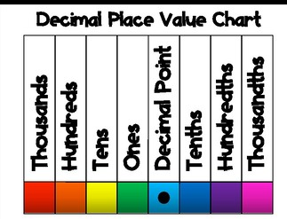 eight hundred seventy-four and five tenths
- Finding Perimeter (3rd Grade, Unit 5)
Make sure you know ALL of the sides. Then add them all up.
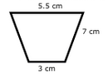
- Rounding to the underlined place value. (4th Grade, Unit 1/5th Grade, Unit 9)
All numbers BEFORE the underlined number stay the same. If the number to the right of the underlined number is 5 or more, the underlined number goes up one. If it is 4 or less, the underlined number stays the same. All numbers AFTER the underlined number turn to 0’s. Any 0’s After a decimal point (no other numbers after them) disappear.
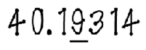
- Adding Fractions (4th Grade, Unit 9/ 5th Grade, Unit 4/7th Grade, Unit 1)
Count by the bottom numbers (denominators) until you get to a number they both share. Make that number your new bottom number. See what you had to multiply each bottom number by to get to the new number. Multiple each top number (numerator) by the same thing to get equivalent fractions. Add the numerators, keep the denominator the same. Reduce if needed.
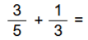
- Subtracting Fractions (4th Grade, Unit 9/ 5th Grade, Unit 4/ 7th Grade, Unit 1)
Count by the bottom numbers (denominators) until you get to a number they both share. Make that number your new bottom number. See what you had to multiply each bottom number by to get to the new number. Multiple each top number (numerator) by the same thing to get equivalent fractions. Subtract the numerators, keep the denominator the same. Reduce if needed.
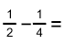
- Adding Decimals (5th Grade, Unit 10/6th Grade, Unit 1/7th Grade, Unit 1)
Write the numbers vertically (up and down). Remember to line up your decimal points. Annex 0’s to fill in any missing spots at the start or end of a number (NOT IN THE MIDDLE). Start on the right and work left.
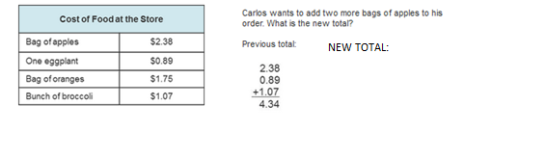
- Subtracting Decimals (5th Grade, Unit 10/6th Grade, Unit 1/7th Grade, Unit 1)
Write the numbers vertically (up and down). Remember to line up your decimal points. Annex 0’s to fill in any missing spots at the start or end of a number (NOT IN THE MIDDLE). Start on the right and work left.
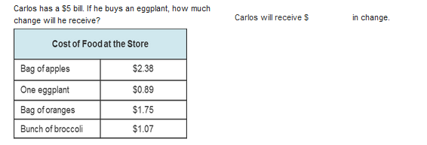
- Plotting the coordinates and finding the distance between the 2 points (5th Grade, Unit 8/6th Grade, Unit 6)
The 1st number tells you to go left (-) or right (+). The 2nd number tells you to go up (+) or down (-). Each set of parentheses makes ONE dot.
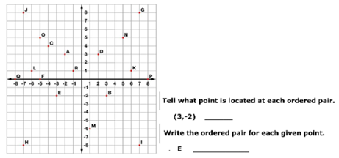
- Finding Volume (5th Grade, Unit 3/ 6th Grade, Unit 8/7th Grade, Unit 7)
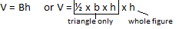
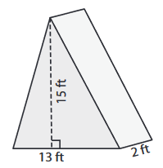
- Graphing an inequality (6th Grade, Unit 4/7th Grade, Unit 4)
Decide if you want an open dot ( o < or >) or a closed dot ( < or >) on the number shown. Then decide if the variable (letter) is smaller than the number or bigger than the number. Shade in the appropriate direction.
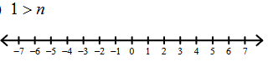
- Multiplying Decimals (6th Grade, Unit 1/7th Grade, Unit 1)
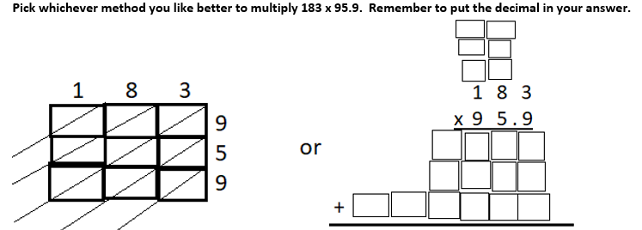
- Dividing Decimals (6th Grade, Unit 1/7th Grade, Unit 1)
If there is a decimal outside of the division sign, you must move it to the end of the number. However many spaces you move it, you must move the decimal under the division sign the same number of spaces. (If you don’t see a decimal point, it goes at the end of the number. Bring the decimal point straight up on top of the division bar. List the multiples of the outside number.
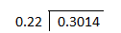
- Solving an equation (6th Grade, Unit 4/7th Grade, Unit 4)
Draw a line on the equal sign to separate the two sides of the equation. Put a box around the variable (letter). The variable will stay in the same spot throughout the problem. Add or subtract (do the opposite of what it says) the number not directly attached to the variable (do the same exact thing to both sides of the equal sign to make a new equation). Then multiply or divide (do the opposite of what it says) the number attached to the variable (do the same exact thing to both sides of the equal sign to find your solution.
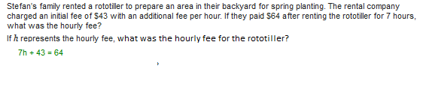
- Using Order of Operations (6th Grade, Unit 4)
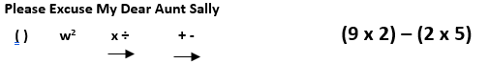
- Adding Integers (7th Grade, Unit 1)
If both numbers have the same sign (both positive or both negative), just add then and take the sign.
If the numbers have different signs, then subtract them and take the sign of the larger number (what would be larger without the signs).
-11 + -98
- Subtracting Integers (7th Grade, Unit 1)
Always start by Adding the Opposite (change the subtraction operation to addition, then change the sign of the number AFTER the operation). Now you have an addition problem and can follow the rules for adding integers.
- Finding an unknown angle measure (7th Grade, Unit 5)
All angles in a triangle will equal 180 degrees.
All angles in a straight line will equal 180.
All angles in a right angle will equal 90 degrees.
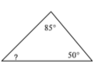
- Solving proportions (7th Grade, Unit 2)
Cross multiply a top number and a bottom number on opposite sides of the equal sign.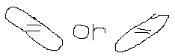
Then divide by the remaining number. You may use a calculator for this one, but show what you did.
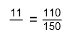
- Finding probability (7th Grade, Unit 9)
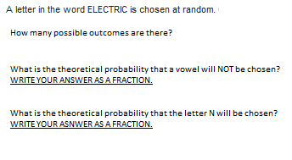
- Solving 2-way Tables
