6th Grade Homework 2020-2021 #5 https://mrsbarnard.webnode.com/ Name __________________________

- Counting Money (2nd Grade, Unit 11)
Quarter = 0.25, Dime = 0.10, Nickel = 0.05, Penny = 0.01
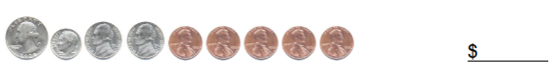
- Telling Time (2nd Grade, Unit 10/3rd Grade, Unit 8)
Look at the shorter hand first. It will tell you the hour. If it is between 2 numbers, take the number to the left). Next, look at the longer hand. Starting at 12 and going to the right, count each tick mark until you get to where the hand is pointing. You can skip count by 5’s to make it easier.
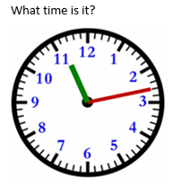
- Writing Decimals (3rd Grade, Unit 1/4th Grade, Unit 1/5th Grade, Unit 9)
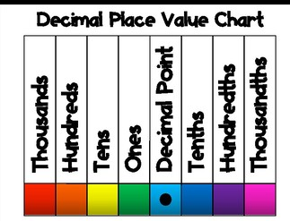 Sixty-eight thousand twenty-nine and five hundredths
- Finding Perimeter (3rd Grade, Unit 5)
Make sure you know ALL of the sides. Then add them all up.
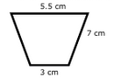
- Multiplying (4th Grade, Unit 4/ 5th Grade, Unit 1)
Pick whichever method you like better to multiply 183 x 95.9. Remember to put the decimal in your answer.
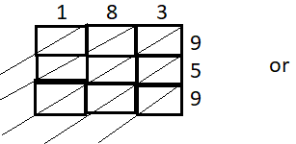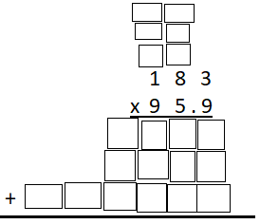
- Dividing (4th Grade, Unit 5/ 5th Grade, Unit 1)
List the multiples of the outside number first.
- Adding Decimals (5th Grade, Unit 10)
Write the numbers vertically (up and down). Remember to line up your decimal points. Annex 0’s to fill in any missing spots at the start or end of a number (NOT IN THE MIDDLE). Start on the right and work left.
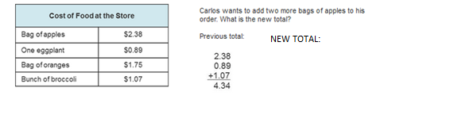
- Subtracting Decimals (5th Grade, Unit 10)
Write the numbers vertically (up and down). Remember to line up your decimal points. Annex 0’s to fill in any missing spots at the start or end of a number (NOT IN THE MIDDLE). Start on the right and work left.
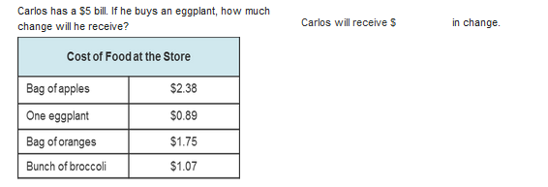
- Dividing Fractions (5th Grade, Unit 6)
Use the check method if you have mixed numbers. Then do Keep the first fraction, Change the operation to multiplication, Flip the last fraction (KCF). Multiply the numerators (top). Multiply the denominators (bottom). Reduce if needed.
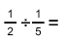
- Writing Expressions (5th Grade, Unit 2)
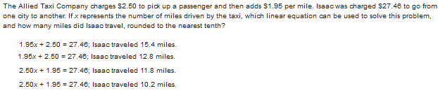
- Writing Ratios
Write the ratio as a fraction. Reduce if needed.
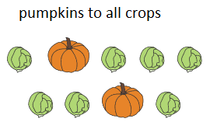
For numbers 12-15 use the following information. Remember to put the numbers in order from least to greatest first.
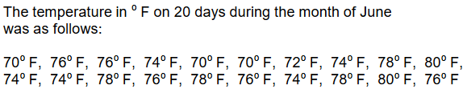
- Finding Mode
The number that is repeated the most often.
- Finding Median
The number in the middle. If you have 2 numbers in the middle, you need to add the 2 numbers together and divide by 2.
- Finding Range
The biggest number minus the smallest number.
- Finding Mean
Add up all of the numbers. Divide the total by how many numbers there are in the data set.
- Graphing an Inequality
Decide if you want an open dot ( o < or >) or a closed dot ( < or >) on the number shown. Then decide if the variable (letter) is smaller than the number or bigger than the number. Shade in the appropriate direction.
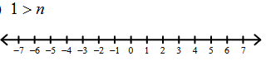
- Rounding (4th Grade, Unit 1/5th Grade, Unit 9)
All numbers BEFORE the underlined number stay the same. If the number to the right of the underlined number is 5 or more, the underlined number goes up one. If it is 4 or less, the underlined number stays the same. All numbers AFTER the underlined number turn to 0’s. Any 0’s After a decimal point (no other numbers after them) disappear.
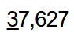
- Turning Mixed Numbers into Improper Fractions
Use the check method. Multiply the whole number by the denominator (bottom number). Then add the numerator (top). This will be your new numerator. The denominator will stay the same.
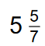
- Plotting the coordinates and finding the distance between the 2 points (5th Grade, Unit 8)
The 1st number tells you to go left (-) or right (+). The 2nd number tells you to go up (+) or down (-). Each set of parentheses makes ONE dot.
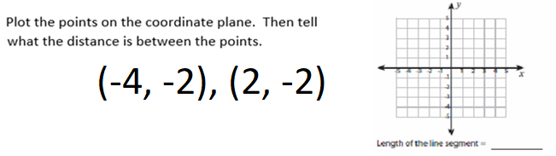
- Solving Equations
Draw a line on the equal sign to separate the two sides of the equation. Put a box around the variable (letter). The variable will stay in the same spot throughout the problem. Add or subtract (do the opposite of what it says) the number not directly attached to the variable (do the same exact thing to both sides of the equal sign to make a new equation). Then multiply or divide (do the opposite of what it says) the number attached to the variable (do the same exact thing to both sides of the equal sign to find your solution).
